**Collection Runner:**

First Iam going to choose the collection which I want to run.

Then select the request we want to run, And iteration we want and click Run HTTP the bottom button.

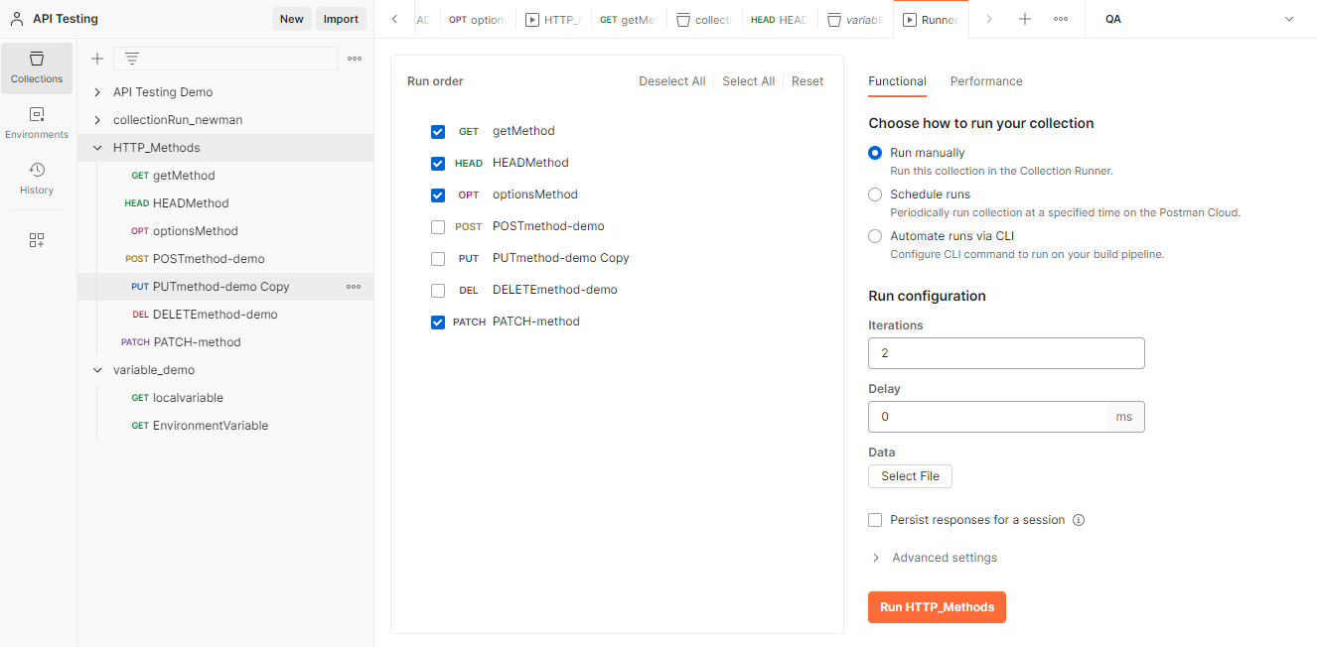

As we can see that the requests starts running and the Two iteration got executed.

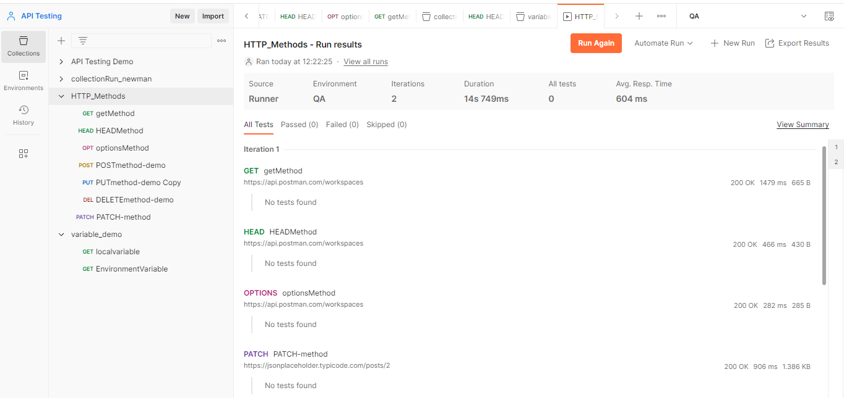

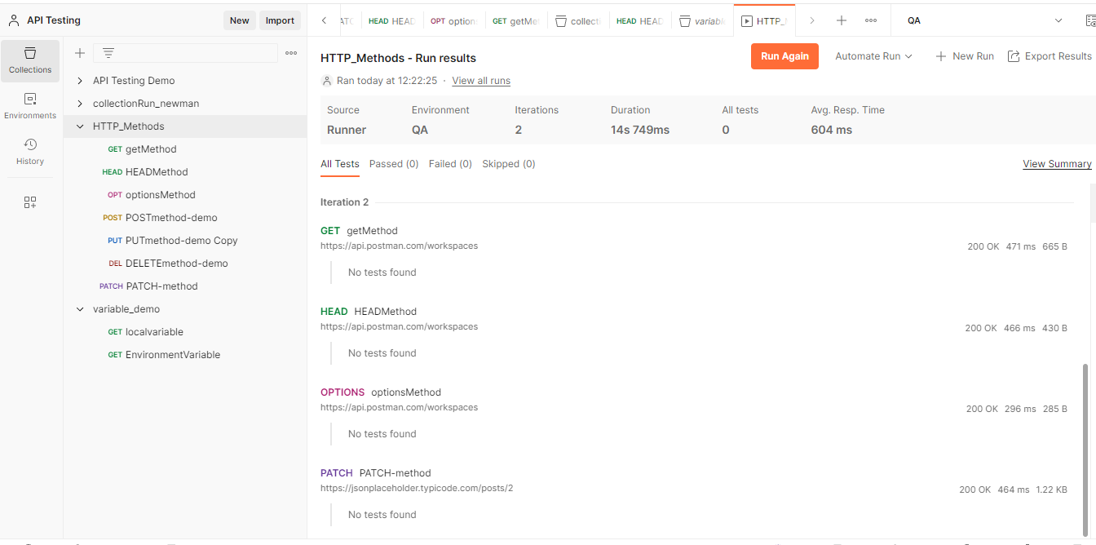

As we can see below if we click on collection under Run it will shows the collection run.

